# Assignment 2 – MySQL

**Group**: 23

**Students**: Dries Costermans, Tibo Van den Eede, Marco Zoso

**Introduction**

In this assignment, we solved some database tasks using the MySQL database (version 8.0.30) and coding in Python.

In the first part of the assignment, we had to set up the database and create tables in MySQL with their attributes. After this, the data had to be inserted into the database.

In the second part the queries were written and executed.

You can find our git repository in the following link: https://github.com/tiboat/tdt4225_assignment2.git

**Discussion**

We tried to follow the instructions as it was explained on the assignment sheet. We learned that writing queries in an efficient way and having a well-structured database is important especially when the database is rather large. As a user, you don't want to wait too long if you want to do a simple query. In addition, we improved our SQL skills.

# Results of queries:

1. How many users, activities and trackpoints are there in the dataset (after it is inserted into the database).

In the dataset there are 182 users, 16048 activities and 9681756 trackpoints.

2. Find the average number of activities per user.

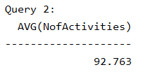

3. Find the top 20 users with the highest number of activities.

4. Find all users who have taken a taxi.

5. Find all types of transportation modes and count how many activities that are tagged with these transportation mode labels. Do not count the rows where the mode is null.

6. a) Find the year with the most activities.

b) Is this also the year with most recorded hours?

No, while 2008 has the most activities, 2009 has the mos recorder hours.

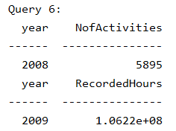

7. Find the total distance (in km) walked in 2008, by user with id=112.



8. Find the top 20 users who have gained the most altitude meters.

9. Find all users who have invalid activities, and the number of invalid activities per user

10. Find the users who have tracked an activity in the Forbidden City of Beijing.

11. Find all users who have registered transportation_mode and their most used transportation_mode.

**Feedback**

In our opinion, this assignment is not highly related to the course content we have seen so far. Hence, it would be nice if the assignment has a bigger overlap with the course content.